**“AppFusion: Where Apps Align with Your Desires”**

**TEAM**

Anushree Kolhe

Kaushik Parvathaneni

Shubhangi Dabral

**PROJECT SUMMARY**

Our goal with this project is to develop a cutting-edge app recommendation system. We've gathered a vast amount of app data, boasting over 1.2 million records sourced from the Apple App Store, courtesy of Kaggle. The team will focus on enhancing how people discover and receive app recommendations, primarily through a dedicated database project.

We're strongly emphasizing data-driven methods, honing in on various attributes within the dataset such as 'App_Name,' 'Primary_Genre,' 'Content_Rating,' and more. The database system will generate personalized app suggestions with meticulous attention to detail. This is possible by allowing users to precisely specify their preferences and consider factors like genre, content rating, and additional app attributes.

The above-presented approach to the app recommendation system aims to boost user engagement and promote well-informed suggestions in mobile apps. Our project places a premium on customization, aiming to offer the ultimate source for those searching for personalized app recommendations. By leveraging the dataset's depth, we aspire to become the top choice for individuals looking for tailored app suggestions and comprehensive insights into the world of mobile applications.

**PROJECT DESCRIPTION**

**Team**

Anushree Kolhe

Kaushik Parvathaneni

Shubhangi Dabral

**Objectives:**

The project's primary objective is to develop a personalized app recommendation system using a comprehensive dataset from Kaggle, focusing on the Apple App Store. This system aims to enhance users' app discovery by tailoring recommendations to their preferences, including app genre, content rating, and various features. Our goals include:

1. **Personalization:** Customize app recommendations for individual users.
2. **Data Utilization:** Optimize suggestions using Apple App Store data.
3. **Cold Start Resolution:** Address new users' 'cold start' problem.
4. **Diverse Recommendations:** Provide various app suggestions to broaden users' horizons.

Our project aims to create a user-friendly recommendation engine that enriches the app discovery experience.

**Usefulness:**

Our database-driven app recommendation system is an essential resource for various user groups. By offering personalized recommendations, it first tackles the typical app discovery problem and enables users to identify programs that match their unique preferences. The project also facilitates informed decision-making by providing in-depth app information, such as user reviews and descriptions. The Apple App Store dataset, which enables a more sophisticated recommendation process, distinguishes our approach from others. This new technology appeals to many people, including app developers, researchers interested in app trends and data analysis, and casual users looking for personalized application recommendations.

Users may easily navigate and explore the world of apps, which supports a fun and straightforward experience. Additionally, the system's ability to offer in-depth app details, like user reviews, download data, and developer information, dramatically improves the quality of app selection. As a result, our database application meets the varied needs of app enthusiasts, regular users, and business people looking for statistical insights into app trends.

**Dataset:**

The dataset is obtained from Kaggle: <https://www.kaggle.com/datasets/gauthamp10/apple-appstore-apps?select=appleAppData.csv>

The dataset we obtained is in the form of CSV. There are more than 1.2 million records in it, and each one has different information like the "App_Name," "Primary_Genre," "Content_Rating," "User_Rating," "Description," and many others. The initial goal of this dataset's collection was app cataloging and analysis. It is a significant resource for our recommendation engine because it offers a variety of data on programs accessible on the Apple App Store.

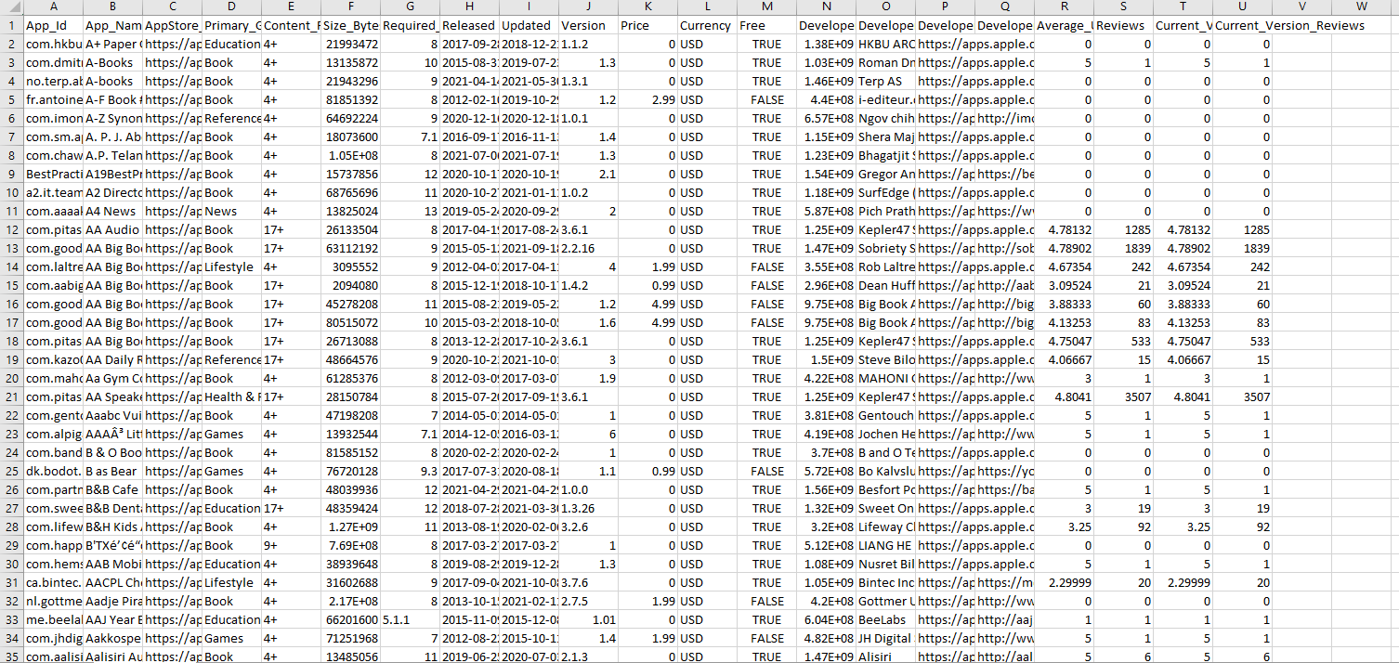

The dataset contains around 1.2 million rows and 22 columns, which describe different features of the apps. The data at hand is extensive for the proposed system. Therefore, the data for the proposed system will be a smaller subset of the comprehensive dataset.

Gautham Prakash created the dataset in October 2021, taking ideas from one designed for Google Play Store apps. It aims to build a comprehensive database of Apple Store applications to support various data-driven projects.

**Communication and Sharing:**

The team communicates regularly through Google Meet. All the project-related files and documents are available in the GitHub repository: <https://github.iu.edu/kaparvat/ADT>.